

**Bachelor of Science in Computer Science Session (2021-2025 Fall)**

**Submitted By**:

**Muhammad Qaiser**

**Saba Fraz**

**SUPERVISOR**

**Dr. Gulzar Ahmad**

HOD

School of Computer Science

**SCHOOL OF COMPUTER SCIENCE MINHAJ UNIVERSITY, LAHORE**

# Project

*Submitted in Partial Fulfillment*

of the Requirements for the Degree of

Bachelor of Science in Computer Science

at the

Minhaj University, Lahore

by

Muhammad Qaiser

Reg. No. 2021f-mulbscs-004

Saba Fraz

Reg. No. 2021f-mulbscs-152

|  |  |
| --- | --- |
| *Supervisor Name*  Supervisor  School of Computer Science | *Dr. Gulzar Ahmad*  Head School of Computer Science |

It is declared that this is an original piece of my work, except where otherwise acknowledged in text and references. This work has not been submitted in any form for another degree or diploma at any university or other institution for tertiary education and shall not be submitted by me in future for obtaining any degree from this or any other University or Institution. I am the responsible if I do not meet the deadline.

Muhammad Qaiser Signature: Reg. No. 2021f-mulbscs-004

Saba Fraz Signature: Reg. No. 2021f-mulbscs-152



# DEDICATION

***To***

***My Mother***

*Who always wished or prayed for my success, for supporting and encouraging me to believe in myself, who always sacrificed so much for me.*

***My Father***

*For earning an honest living for me, for supporting and encouraging me to believe in myself.*

***My Teacher***

*For their support and wishes.*

# CERTIFICATE OF APPROVAL

It is certified that the project titled “Ready Crop: AI Harvest Planner” carried out by Muhammad Qaiser, Reg. No. 2021f-mulbscs-004, Saba Fraz 2021f-mulbscs-152 under the supervision of Dr. Gulzar Ahmad, Minhaj University Lahore, is fully adequate, in scope and in quality, as a final year project for the degree of BS of Computer Science.

Supervisor: --------------------------------

Dr. Gulzar Ahmad

HOD

School of Computer Science Minhaj University Lahore

Internal Examiner 1: -------------------------------

School of Computer Science Minhaj University Lahore

Internal Examiner 2: --------------------------------

School of Computer Science Minhaj University Lahore

FYP Coordinator: --------------------------------

Shoaib Saleem

Lecturer

School of Computer Science Minhaj University Lahore

Head of Department: -----------------------------------

Dr. Gulzar Ahmad

School of Computer Science Minhaj University Lahore

# ACKNOWLEDGEMENT

First of all, I am thankful to Allah Almighty, the most beneficial and merciful who gave me the courage and guidance to complete my project. I offer my special praise for our beloved Holy Prophet Hazrat Muhammad (S.A.W) who is the symbol of knowledge and guidance of humanity as a whole. I like to express my special thanks of gratitude to my supervisor Dr. Gulzar Ahmad for his support. His steadfast support of this project was greatly needed and deeply appreciated. Last but not least, no acknowledgement could ever express our obligations to our loving parents for their love, affection, amiable, advices and prayers for my success.

# ABSTRACT

Agricultural productivity often suffers due to untimely harvesting and lack of real-time crop monitoring, especially for small-scale farmers who lack access to precision farming tools. The Ready Crop project addresses this problem by developing an AI-based solution that predicts plant maturity and harvest readiness using deep learning models. Focused initially on green chili plants, the system uses image-based analysis to estimate crop age and the number of days until harvest, aiming to support timely agricultural decision-making. The research method involves collecting and training a convolutional neural network on labeled plant images, deploying the model via Flask API endpoints, and integrating it with a web-based interface that allows users to upload images for prediction. Supabase PostgreSQL is used as the backend to manage user data securely, while OTP-based email verification ensures authenticated access. Through simulations, the system was evaluated in five scenarios: prediction accuracy under ideal image conditions, handling of OTP expiration and regeneration, multi-crop model deployment with isolated endpoints, performance under noisy or low-quality images, and user experience with OTP input and validation timers. The model achieved over 90% accuracy with high-quality images, while user authentication workflows performed reliably. However, results also showed that prediction performance could drop when image quality was poor, indicating a need for better preprocessing or model robustness. In conclusion, Ready Crop proves to be a scalable and practical application of AI in agriculture, offering farmers and researchers a tool for accurate harvest predictions. With future improvements targeting enhanced image processing, expanded crop support, and user experience refinements, the system has strong potential to support sustainable and smart farming practices on a wider scale.

# TABLE OF CONTENTS

CHAPTER 1 INTRODUCTION 1

* 1. Background 2
  2. Goals and Objectives 2
  3. Gap Analysis 2
  4. Project Plan 3
     1. Work Breakdown Structure 3
     2. Gantt Chart 4
     3. Team Members 5
  5. Report Outline 5

CHAPTER 2 SYSTEM REQUIREMENTS AND SPECIFICATION 6

* 1. Purpose 7
     1. Document Conventions 7
     2. Intended Audience 7
  2. Overall Description 8
     1. Service Perspective 8
     2. Service Function 8
     3. Product Functions 8
     4. User Classes and Characteristics 9
     5. Assumptions and Dependencies 9
  3. External Interface Requirements 9
     1. User Interfaces 9
     2. Hardware Interface 10
     3. Game Interface 10
  4. System Features 10
     1. User Login 10
     2. Logout 11
     3. Edit Settings 11
     4. Play Online 12
  5. Other Nonfunctional Requirements 12
     1. Performance Requirements 12
     2. Safety Requirements 12
     3. Software Quality Attributes 13
  6. Other Requirements 13

CHAPTER 3 USECASE ANALYSIS 14

* 1. Use Case Model 15
  2. Fully Dressed Use Cases 16

CHAPTER 4 SYSTEM DESIGN 28

* 1. Architecture Diagram 29
  2. Domain Model 30
  3. Class Diagram 32
  4. Sequence / Collaboration Diagram 33
  5. Operation Contracts 34
  6. Activity Diagram 37
  7. State Transition Diagram (Login) 38
  8. State Transition Diagram (Edit Settings) 39
  9. State Transition Diagram (Join Game Lobby) 40
  10. State Transition Diagram (Create Lobby) 41
  11. State Transition Diagram (Start Game) 42
  12. Component Diagram 43
  13. Deployment Diagram 44
  14. Game Interference 45
      1. Splash Screen 45
      2. Login Screen 46
      3. Main Menu Screen 47
      4. General Settings 48
      5. Graphics Settings 49
      6. Audio Settings 50
      7. Controls Settings 51
      8. Create Lobby Team Death Match Mode 52
      9. Create Lobby Capture of Flag Mode 53
      10. Create Lobby Free for All 54
      11. Lobby 55
      12. Gameplay 56
      13. Scoreboard 57

CHAPTER 5 IMPLEMENTATION 58

* 1. Important Flow Control 59
  2. Components, Libraries And Stubs 60
  3. Deployment Environment 60
  4. Tools and Techniques 60
  5. Best Practices / Coding Standards 61

CHAPTER 6 TEST AND EVALUATION 62

* 1. Testing and Evaluation 63
  2. Use Case Testing 63
  3. Boundary Value Analysis 65
  4. Performance Testing 66
  5. Stress Testing 69
  6. Improvement 70

REFERENCES 71

Table 1.1 Team Member 5

Table 3.1 Use Case<01> 17

Table 3.2 Use Case<02> 19

Table 3.3 Use Case<03> 21

Table 3.4 Use Case<04> 23

Table 3.5 Use Case<05> 25

Table 3.6 Use Case<06> 27

Table 4.1 Operation Contracts-01 34

Table 4.2 Operation Contracts-02 34

Table 4.3 Operation Contracts-03 35

Table 4.4 Operation Contracts-04 35

Table 4.5 Operation Contracts-05 36

Table 4.6 Operation Contracts-06 36

Table 6.1 Use Case Testing-01 64

Table 6.2 Use Case Testing Extension 65

Table 6.3 Performance Testing 01 66

Table 6.4 Performance Testing 02 66

Table 6.5 Performance Testing 03 67

Table 6.6 Performance Testing 04 67

Table 6.7 Performance Testing 05 68

Table 6.8 Performance Testing 06 68

Figure 1.1 Word Breakdown Structure 3

Figure 1.2 Gantt Chart 4

Figure 3.1 Use Case Model 15

Figure 3.2 Login Use Case 16

Figure 3.3 Edit Profile Use Case 18

Figure 3.4 Join Game Lobby Use Case 20

Figure 3.5 Create Lobby Use Case 22

Figure 3.6 Start Game Use Case 24

Figure 3.7 End Game Use Case 26

Figure 4.1 Architecture Diagram 29

Figure 4.2 Domain Model 30

Figure 4.3 Entity Relationship Diagram 31

Figure 4.4 Class Diagram 32

Figure 4.5 Sequence / Collaboration Diagram 33

Figure 4.6 Activity Diagram 37

Figure 4.7 State Transition Diagram (Login) 38

Figure 4.8 State Transition Diagram (Edit Settings) 39

Figure 4.9 State Transition Diagram (Join Game Lobby) 40

Figure 4.10 State Transition Diagram (Create Lobby) 41

Figure 4.11 State Transition Diagram (Start Game) 42

Figure 4.12 Component Diagram 43

Figure 4.13 Deployment Diagram 44

Figure 4.14 Splash Screen 45

Figure 4.15 Login Screen 46

Figure 4.16 Main Menu Screen 47

Figure 4.17 General Settings 48

Figure 4.18 Graphics Settings 49

Figure 4.19 Audio Settings 50

Figure 4.20 Controls Settings 51

Figure 4.21 Create Lobby Team Death Match Mode 52

Figure 4.22 Create Lobby Capture of Flags Mode 53

Figure 4.23 Create Lobby Free for All 54

Figure 4.24 Lobby 55

Figure 4.25 Gameplay 56

Figure 4.26 Scoreboard 57

Figure 5.1 Important Flow Control 59

# CHAPTER 1 INTRODUCTION

This chapter introduces the foundational aspects of the Ready-Crop project. It includes the background, goals and objectives, gap analysis, proposed solutions, project plan, and an outline of the report. The purpose of this chapter is to establish the motivation behind the project and highlight how it addresses key challenges in agriculture, especially in regions where smart farming is still underdeveloped.

## Background

In many developing countries such as Pakistan, traditional agriculture still dominates. While the world is moving toward data-driven, sensor-enabled farming techniques, these innovations remain inaccessible to a vast majority of small-scale farmers due to high costs, lack of education, or absence of technical infrastructure.

Ready-Crop – AI Harvest Planner is designed to bridge this digital divide. It offers a lightweight, easy-to-use, AI-powered solution that helps farmers—both rural and urban—track plant growth stages and predict harvest time without expensive sensors or IoT devices. All that’s needed is a smartphone camera and internet access.

The tool is equally beneficial for urban plant growers and home gardeners who want to track indoor plants. By leveraging artificial intelligence for image classification and smart scheduling, Ready-Crop promotes accessible smart agriculture with minimal requirements.

## Goals and Objectives

The main aim of Ready-Crop is to enable digital farming practices in under-resourced areas by removing barriers such as cost, complexity, and technical skill. The project’s objectives are:

* Predict the current growth or harvest stage of a plant using AI and a simple image input.
* Allow users to save plant records for future tracking and monitoring.
* Send intelligent reminders and notifications as the predicted harvest time approaches.
* Offer manual plant record entry in case the user doesn't trust the AI prediction or the plant type is not yet supported.
* Eliminate the dependency on physical sensors or technical configurations to support widespread use, especially in regions like Pakistan.

## Gap Analysis

Despite the growing popularity of smart farming globally, the majority of small-scale farmers in countries like Pakistan still rely on traditional methods. Existing smart agriculture systems often depend on expensive hardware, trained personnel, and reliable environmental sensors—none of which are common in rural or lower-income settings.

Ready-Crop fills this gap by:

* Providing a sensor-free solution using AI-powered plant stage prediction based on images.
* Delivering a user-friendly interface that requires minimal training or background knowledge.
* Supporting manual input for users who are already experienced or are growing unsupported plants.
* Offering an affordable, scalable, and internet-based solution that’s practical even in remote areas with limited resources.

## Project Plan

**Workflow:**

Users register through a secure email-OTP authentication system. Once logged in, they can upload plant images to receive harvest stage predictions using a YOLO-based machine learning model. Users can then save, view, or delete plant records. The system also sends automated email reminders when the harvest time is approaching (e.g., 3 weeks or 1 week remaining). Additionally, users have the option to manually add plant records without using the AI prediction model.

Features:

* Email-based OTP authentication for secure user access
* YOLOv8 model for plant stage classification
* Supabase PostgreSQL for managing user and plant record storage
* Automated email reminders based on harvest timelines
* Manual entry support for plant records without AI prediction
* Scalable model architecture with planned support for additional plant types in the future

### Work Breakdown Structure

The Work Breakdown Structure (WBS) for the Ready-Crop project is as follows:

1. **Requirements & Planning**

* Define project scope and objectives
* Identify supported plant types and prediction logic
* Establish technology stack (Flask, Angular, Supabase, etc.)

1. **Authentication System**

* Implement email-based OTP registration and login
* Validate users securely via OTP expiration and resend logic
* Manage session tokens and authorization headers

1. **Machine Learning Integration**

* Integrate YOLOv8 model for plant stage prediction
* Handle image uploads and preprocessing
* Define class mapping and filtering logic

1. **Plant Record Management**

* Develop APIs to save, view, and delete records
* Handle logic for manual vs. predicted entries
* Link records with authenticated users

1. **Email Notification System**

* Implement scheduled tasks to trigger email reminders
* Determine harvest timelines (3 weeks, 1 week remaining)
* Integrate with SMTP services for email delivery

1. **Frontend Development**

* Design user interfaces for login, upload, prediction results, and record management
* Build OTP dialogs, image preview, and status messages
* Integrate APIs with Angular services

1. **Testing**

* **Unit testing of individual backend components**
* **Integration testing of APIs and database interactions**
* **End-to-end testing of user workflows, including:**
* **OTP-based registration and login**
* **Image upload and prediction retrieval**
* **Plant record saving and manual entry**
* **Email reminder logic and triggers**

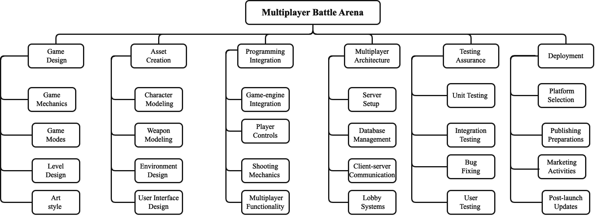

**Figure 1.1 Word Breakdown Structure**

### Gantt Chart

A Gantt chart for game development is a project management tool that visually represents the various tasks and stages involved in creating a game. It breaks down the development process into smaller, manageable tasks, such as design, art, programming, and testing, and arranges them on a timeline. The chart shows the duration of each task, task dependencies, and important milestones. Team members can be assigned to specific tasks, and progress is regularly updated to track actual progress against the planned schedule. By using a Gantt chart, game developers can effectively plan, coordinate, and monitor the development process, ensuring a smoother and more efficient game creation journey.

In summary, a Gantt chart is a game development roadmap that streamlines the project's tasks, resources, and timelines. It keeps the development team organized, improves communication, and enables better decision-making, ultimately leading to a successful and well-managed game development process.

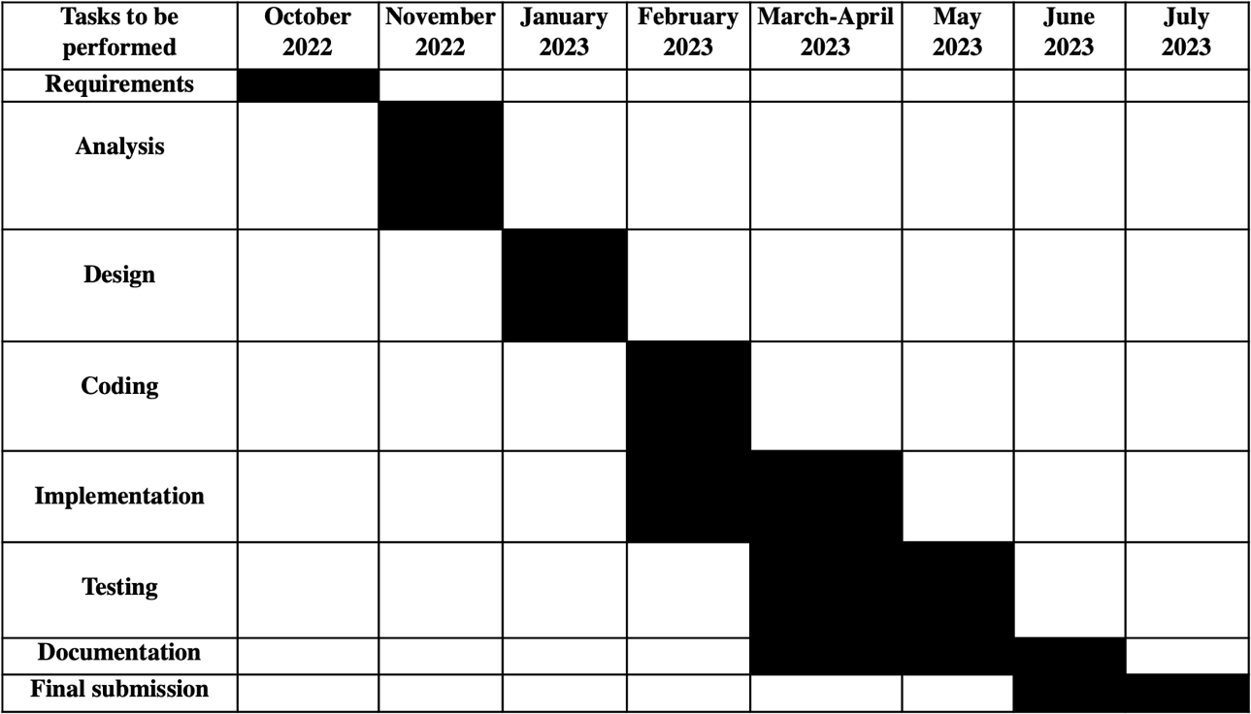

**Figure 1.2 Gantt Chart**

Team consists of

* + - * Project Manager (PM)
      * Requirement Analyst (RA)
      * Backend Developers
      * Frontend developers
      * Testing Engineering (TE)

Each member has some specific skills which they used efficiently in project. A table in given to show team members names, their skills and their task description.

**Table 1.1 Team Member**

|  |  |  |
| --- | --- | --- |
| **Name** | **Skills** | **Description** |
| Haider Raza | Back-end Developers Front-end Developer | Involved in coding  Design The User Interface |

## Report Outline

Multiplayer Battle Arena provides a friendly user interface to the users. All the features are easy to understand.

* Game modes: Team Deathmatch, Free for All, and Capture of Flag.
* Player team system.
* Shooter AI (Bots).
* 6 different types of weapons: Rifle, Sniper, Shotgun, Pistol, Grenade, and Knife.
* Walk, Slide, Jump, Crouch, Shoot, Die, and Run player animations.

# CHAPTER 2

**SYSTEM REQUIREMENTS AND SPECIFICATION**

The purpose of an online shooting game is to provide an exhilarating and immersive gaming experience. Players engage in virtual combat, showcasing their skills, strategic thinking, and teamwork. These games offer entertainment and escapism, allowing players to enter thrilling virtual worlds. They foster social interaction by enabling players to team up with friends and join communities. With intense gameplay and a sense of achievement, online shooting games aim to deliver adrenaline-pumping action. The ultimate goal is to create an enjoyable and memorable experience that keeps players engaged and coming back for more.

### Document Conventions

When writing the SRS document for "Multiplayer Battle Arena" the following terminologies are used to make the document more effective and readable we used font:

* + - * Times New Roman
      * Line spacing: 2 line spacing
      * Font Size: 12pt
      * headings: 16pt
      * Headings are bold.

This document is intended to the audience and also for those End Users who really want to know for what purpose this game is developed for.

### Intended Audience

People of all age groups owing a computer system or laptop.

### Service Perspective

The online 3d multiplayer shooting game is developed to help people communicate during the game with others easily. The game is developed using c sharp as programming language and design and coded in Unity 3D.

### Service Function

The main function of this project is the multiplayer matchmaking and player communicating. These functions enhance the gaming experience by facilitating fair match ups and enabling collaboration among players.

### Product Functions

#### Features

* + - * Login (as guest)
      * Matchmaking
      * Chat Communication
      * Multiple play modes
      * Spectator Mode
      * Graphics Settings

#### User Function

* + - * Login
      * Select Mode
      * Edit Settings
      * Play Game-play

##### Admin

The administrator can add, edit or delete user’s accounts. Admin manages all functionality of Multiplayer Battle Arena.

#### Design and Implementation Constraints:

* + - * The device will have 8GB RAM.
      * Good quality Internet connection required.
      * Operating System Windows or Macintosh.

##### Tools

* + - * Unity 3D
      * Photon Unity Networking
      * C#

### 2.2.5. Assumptions and Dependencies

In this game, the user must login as a guest. User must have a computer or laptop and at least 4 GB Ram in system. Also, the user must have internet access because Multiplayer Battle Arena is an online game.

## External Interface Requirements

### User Interfaces

The game provides a user-friendly and interactive user interface. In this game, the user will easily understand the use of every element and enjoy the user experience.

User can interact with following things:

* + - * User can play the game in multiple modes.
      * Chat with your team members while in the match.
      * Processor: i3
      * Hard Disk: 5 GB
      * Memory: 4 GB RAM
      * Laptop or computer.

### Game Interface

* + - * Unity 3D
      * Photon Unity Networking
      * C#

## System Features

### User Login

##### Description Priority

User Login has a priority value. Whenever the user installs the game and working for the first time, he/she has to get login first as a guest

##### Stimulus/Response Sequences

* + - * The game launched from the login screen.
      * User is prompted to main menu.

##### Functional Requirements

User gets registered and is able to use the game.

##### Description and Priority

User has to authenticate if he/she is not logged in. He/she can also log out if wanted. This feature has 2nd highest priority at most.

##### Stimulus/Response Sequences

* + - * The game launched from the login screen.
      * User is prompted to main menu.
      * Multiple options show to play the game.
      * If the user is logging out, simply user back to login screen.

##### Functional Requirements

User gets logged in/ logged out

### Edit Settings

##### Description and Priority

This feature is specifically for those users who want to change the settings according to their systems.

##### Stimulus/Response Sequences

* + - * The user chooses settings option from main menu.
      * Change settings according to his requirements.

##### Functional Requirements

User must be logged in and stay connected with internet.

##### Description and Priority

This feature is specifically for those users who want to play game online.

##### Stimulus/Response Sequences

* + - * The user can play the game with online people.
      * User can play the game in 3 different modes.

##### Functional Requirements

User must be logged in and stay connected with internet.

## Other Nonfunctional Requirements

### Performance Requirements

* + - * System device should have Window or Macintosh operating system.
      * User must have a good internet connection to really enjoy the performance of game.
      * Size of the game should be small that it can be accessible in every system if system is low storage device.

### Safety Requirements

Only authorized member or user can log in into a game. Data should be saved in encrypted form so that in case of attack or hack data will be unreadable or unacceptable.

Privacy and security of the user is our basic and most important motive.

##### Availability

Users can access their accounts anytime anywhere.

##### Integrity

Better component design to get better performance at peak time.

##### Correctness

Game is design in that way that it should be free from errors.

##### Reliability

Game is reliable and the user can trust that it's 100% reliable.

##### Security

Game is 100% secure and users save their data with no worry. Before storing data on a database, data is encrypted so that no one can access or steal user's personal information.

##### Easy to Use

Game is easy to use and learn.

## Other Requirements

The system must store the entire User information. For each user data saved with its unique id in the database.

# CHAPTER 3 USECASE ANALYSIS

A use case model is a visual representation in software development that describes how users interact with a system to achieve specific tasks or goals. It consists of use cases, which represent individual functionalities or interactions, and actors, who are the users or external entities interacting with the system.

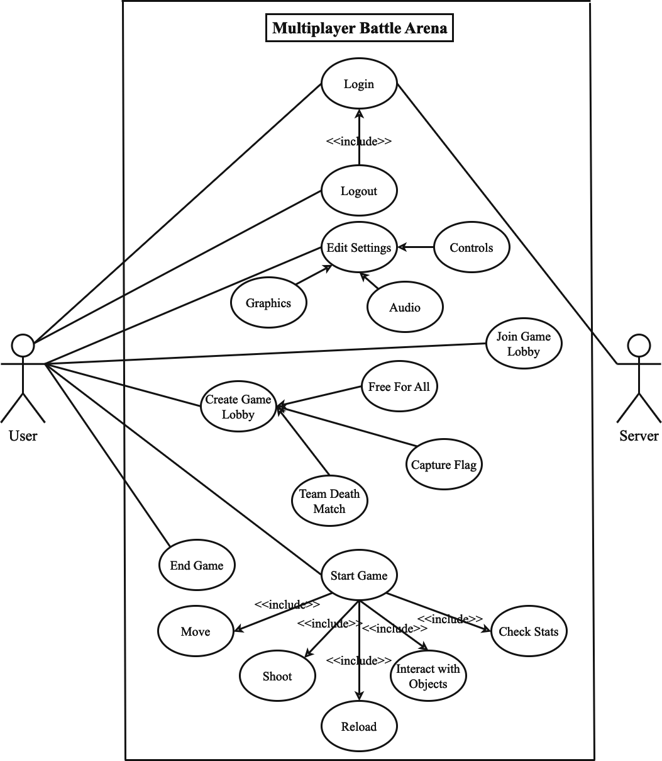

**Figure 3.1 Use Case Model**

##### Guest Login

The "Guest Login" use case for a this game represents a scenario where a player can access and play the game without the need to create an account or log in with formal credentials. Here's a description of the "Guest Login" use case for a shooting game:

The "Guest Login" use case in a shooting game allows players to quickly jump into the action without the friction of creating an account. It caters to casual players who want to experience the game without any commitment, while still providing them with an enjoyable gaming experience.

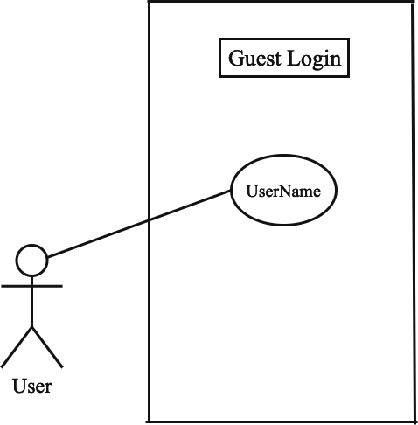

**Figure 3.2 Login Use Case**

**Table 3.1 Use Case<01>**

|  |  |  |
| --- | --- | --- |
| **Fully Dressed Use Case** | | |
| · | **Use Case Name** | Guest Login |
| · | **Scope** | Login |
| · | **Level** | User goal |
| · | **Actor** | User, Server |
| · | **Stakeholder** | User, Server |
| · | **Pre-Condition** | Internet Connection |
| · | **Post-Condition** | Access to game |
| · | **Success Scenario** | Successfully Login |

##### Edit Settings

The "Edit Settings" use case in a multiplayer shooting game represents a scenario where the player wants to customize various game settings to tailor the gameplay experience to their preferences. The setting for this game includes:

* General Settings
* Audio Settings
* Graphics Settings
* Controls Settings

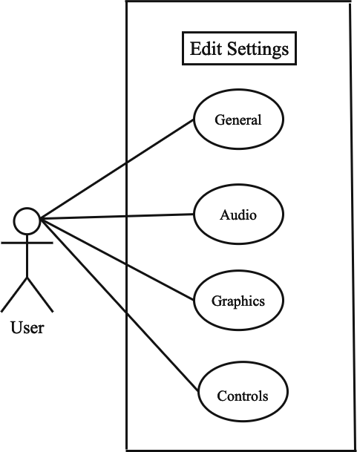

**Figure 3.3 Edit Profile Use Case**

**Table 3.2 Use Case<02>**

|  |  |  |
| --- | --- | --- |
| **Fully Dressed Use Case** | | |
| · | **Use Case Name** | Edit Setting (General, Graphics, Audio, Control) |
| · | **Scope** | Settings |
| · | **Level** | User Goal |
| · | **Actor** | User |
| · | **Stakeholder** | User |
| · | **Pre-Condition** | Internet connection  Must be login |
| · | **Post-Condition** | Settings should be edit |
| · | **Success Scenario** | Settings edit successfully |

##### Join Game Lobby

The "Join Lobby" use case in a shooting game represents a scenario where a player wants to join an existing multiplayer lobby to participate in online matches with other players. The "Join Lobby" use case is a crucial aspect of a shooting game, as it allows players to engage in real- time battles with other players, fostering competition and community engagement. By providing a seamless and user-friendly lobby joining process, the game enhances the overall multiplayer experience and keeps players immersed in dynamic and challenging gameplay. Randomly join the looby in this game.

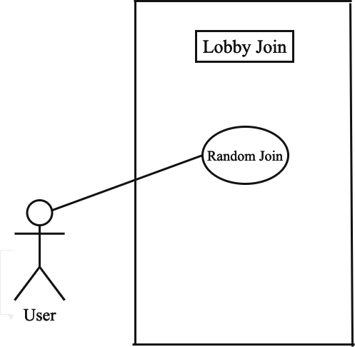

**Figure 3.4 Join Game Lobby Use Case**

**Table 3.3 Use Case<03>**

|  |  |  |
| --- | --- | --- |
| **Fully Dressed Use Case** | | |
| · | **Use Case Name** | Join Game Lobby |
| · | **Scope** | Lobby |
| · | **Level** | User Goal |
| · | **Actor** | User |
| · | **Stakeholder** | User |
| · | **Pre-Condition** | Must be Login Internet Connection |
| · | **Post-Condition** | Join any lobby |
| · | **Success Scenario** | Lobby joined successfully. |

##### Create Game Lobby

The "Create Lobby" use case in a shooting game represents a scenario where a player wants to create a new multiplayer lobby to host a custom game session and invite other players to join. The "Create Lobby" use case empowers players to have control over the multiplayer experience by enabling them to create customized game sessions with friends or other players. It enhances social interaction and player engagement within the shooting game, fostering a sense of community and camaraderie among players. To create the lobby there are three different modes for this game:

* Free for all
* Team death match
* Capture the flags

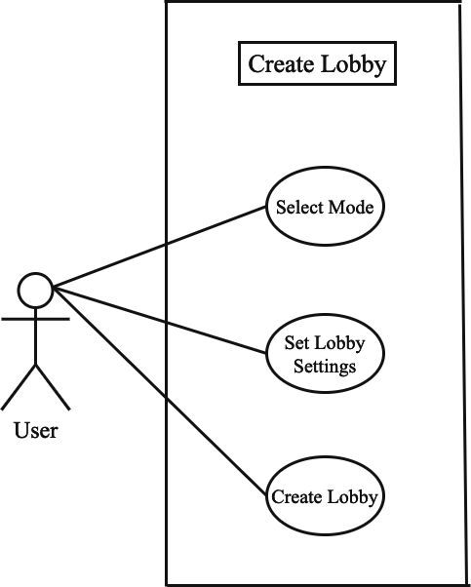

**Figure 3.5 Create Lobby Use Case**

**Table 3.4 Use Case<04>**

|  |  |  |
| --- | --- | --- |
| **Fully Dressed Use Case** | | |
| · | **Use Case Name** | Create Game Lobby |
| · | **Scope** | Lobby |
| · | **Level** | User Goal |
| · | **Actor** | User |
| · | **Stakeholder** | User |
| · | **Pre-Condition** | Must be Login Internet Connection  User must have to select mode  User must set all settings for the mode |
| · | **Post-Condition** | Create a new lobby |
| · | **Success Scenario** | Lobby created Successfully |

##### Start Game

The "Start Game" use case in a shooting game represents a scenario where a player initiates the beginning of a single-player or multiplayer match. The "Start Game" use case is critical in providing players with the opportunity to begin their shooting game experience, whether in a single-player campaign or a competitive multiplayer match. It ensures a smooth and engaging transition from the main menu or lobby to the actual gameplay, providing players with thrilling and immersive shooting game action.

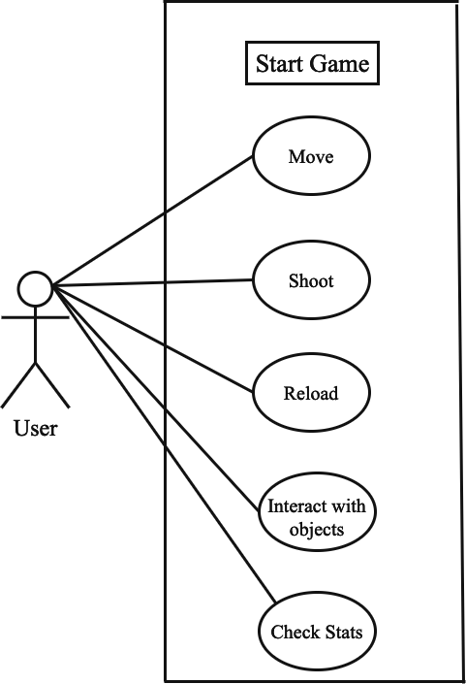

**Figure 3.6 Start Game Use Case**

**Table 3.5 Use Case<05>**

|  |  |  |
| --- | --- | --- |
| **Fully Dressed Use Case** | | |
| · | **Use Case Name** | Start Game |
| · | **Scope** | Game |
| · | **Level** | User Goal |
| · | **Actor** | User |
| · | **Stakeholder** | User |
| · | **Pre-Condition** | Must be Login Internet Connection  User must be join/create lobby |
| · | **Post-Condition** | Start Game |
| · | **Success Scenario** | Game started successfully |

##### End Game

The "End Game" use case in a shooting game represents a scenario where the game session concludes, and the player's participation in the match or campaign comes to an end. The "End Game" use case ensures a smooth and satisfying conclusion to each game session, providing players with feedback on their performance and achievements. It offers closure to the gaming experience while also encouraging players to continue their journey in the shooting game, whether through progression to the next level or exploring other gameplay options.

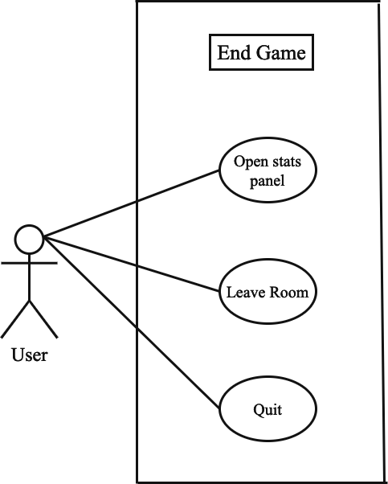

**Figure 3.7 End Game Use Case**

**Table 3.6 Use Case<06>**

|  |  |  |
| --- | --- | --- |
| **Fully Dressed Use Case** | | |
| · | **Use Case Name** | End Game |
| · | **Scope** | Game |
| · | **Level** | User Goal |
| · | **Actor** | User |
| · | **Stakeholder** | User |
| · | **Pre-Condition** | Must be Login  Internet Connection |
| · | **Post-Condition** | Game End |
| · | **Success Scenario** | Game Ended Successfully |

# CHAPTER 4 SYSTEM DESIGN

The system design describes the system requirement, operating environment system and subsystem architecture, files and database design, input format, output layout, user interface, detailed design processing logic, an external interface.

## Architecture Diagram

We divided system architecture in three-part Game, services & authentication and Photon Unity Networking (PUN), As Shown in the figure.

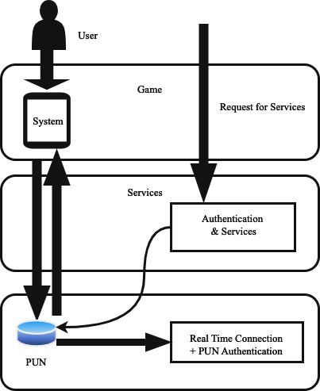

**Figure 4.1 Architecture Diagram**

The multiplayer shooting game's domain model includes entities like "Player" (Player ID, Username, Health, Ammo, Score, Team), "Lobbies" (for match participation), "Teams" (in team-based gameplay), "Weapon" (Weapon ID, Name, Damage, Ammo Capacity), "Power- Ups" (temporary advantages), and "Map" (game environments with distinct characteristics and objectives).

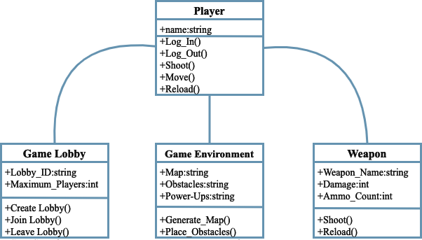

**Figure 4.2 Domain Model**

Entity-Relationship Diagram (ERD) for a multiplayer shooting game. An ERD is a visual representation of the database schema and the relationships between entities. an ERD for a multiplayer shooting game, and in a real-world scenario, the ERD might include additional entities and relationships based on the complexity of the game and its features.

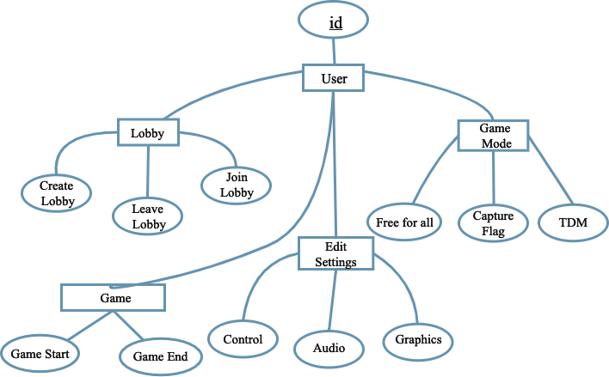

**Figure 4.3 Entity Relationship Diagram**

Class diagram can be quite extensive and might include various classes, attributes, methods, and relationships. an actual multiplayer shooting game, the class diagram may include more classes and complex relationships to model all the game's features and interactions. In this game classes diagram includes:

* Player
* Game lobby
* Game environement
* Weapon



**Figure 4.4 Class Diagram**

In a sequence diagram for a multiplayer shooting game, the interaction between players and the game server during a match is illustrated. It includes events such as players shooting each other. For example, when "Player A" requests to shoot, the message is sent to the game server. The server notifies "Player A" of the shoot request and checks its validity, determining if "Player B" is hit. If the shot is valid, "Player B" is notified of being hit. This sequence depicts the basic flow of shooting actions between players and the game server in a multiplayer shooting game.

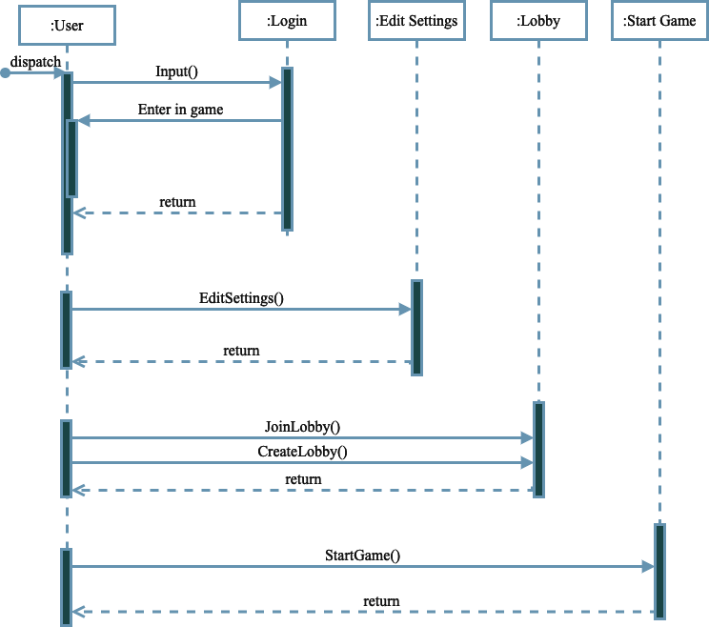

**Figure 4.5 Sequence / Collaboration Diagram**

##### Operation Contracts #1

**Table 4.1 Operation Contracts-01**

|  |  |
| --- | --- |
| **Operation Name:** | Login (username) |
| **Cross Reference:** | Use case Login |
| **Pre-condition:** | User should be online |
| **Post-condition: -** | User will be successfully log in and enter into the timeline  **Objective:** User  **Attribute:** (username)  **Association:** the relationship between user and login |

##### Operation Contracts #2

**Table 4.2 Operation Contracts-02**

|  |  |
| --- | --- |
| **Operation Name:** | Edit Settings (General, Graphics, Audio, Controls) |
| **Cross Reference:** | Use case Edit Settings |
| **Pre-condition:** | User should be online |
| **Post-condition: -** | User will be associated with profile (login)  **Objective:** User  **Attribute:** (General_Settings, Graphics_Settings, Audio_Settings, Controls_Settings)  **Association:** relationship between user and Settings |

|  |  |
| --- | --- |
| **Operation Name:** | Join Lobby |
| **Cross Reference:** | Use case Join Lobby |
| **Pre-condition:** | User should be logged in and online |
| **Post-condition: -** | The Lobby joined randomly  **Objective:** User  **Attribute:** Free for all, Capture flags, Team death match  **Association:** the relationship between user and lobby |

##### Operation Contracts #4

**Table 4.4 Operation Contracts-04**

|  |  |
| --- | --- |
| **Operation Name:** | Create Lobby |
| **Cross Reference:** | Use case Create Game Lobby |
| **Pre-condition:** | User should be logged in and online |
| **Post-condition: -** | User created game lobby successfully  **Objective:** User  **Attribute:** (game mode, max players, room time limit, game goal, after finish, team selection, bots) **Association:** relationship between user and Lobby |

|  |  |
| --- | --- |
| **Operation Name:** | Start Game |
| **Cross Reference:** | Use case Start Game |
| **Pre-condition:** | User should be logged in and online |
| **Post-condition: -** | Game start successfully  **Objective:** User  **Attribute:** (move, shoot, reload, interact with object, check stats)  **Association:** relationship between user and game |

##### Operation Contracts#6

**Table 4.6 Operation Contracts-06**

|  |  |
| --- | --- |
| **Operation Name:** | Logout (user Id) |
| **Cross Reference:** | Use case Logout |
| **Pre-condition:** | User should be logged in and online |
| **Post-condition: -** | User will be logged out **Objective:** User **Attribute:** (user Id)  **Association:** the relationship between user and Logout |

## 4.7. Activity Diagram

In the activity diagram of a multiplayer shooting game, players join the lobby, select game settings, and proceed to gameplay. During the match, they engage in shooting actions and interact with the game environment. Decision points check for hits and match objectives. The diagram visually represents the dynamic flow of activities in the game, ensuring a concise overview of the gameplay process.

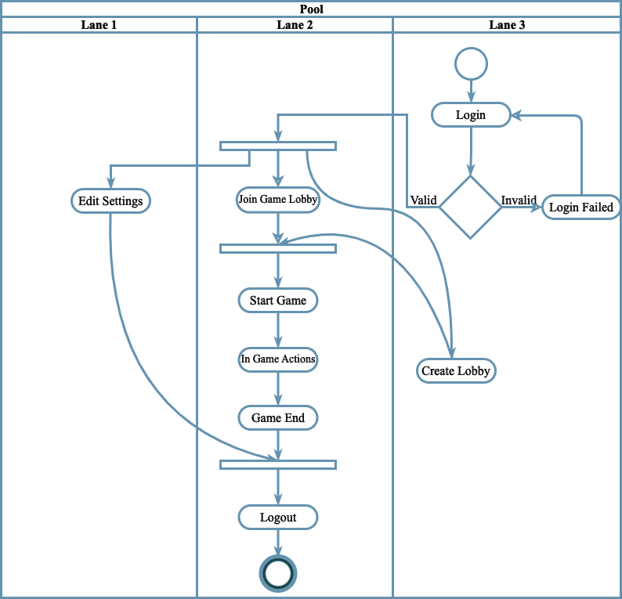

**Figure 4.6 Activity Diagram**

A State Transition Diagram, also known as a State Machine Diagram, represents the various states and transitions of an object or system. For the "Guest Login" use case, the State Transition Diagram will illustrate the different states that a guest user can go through during the login process. Since the "Guest Login" use case involves a simple login without credentials, the diagram will be relatively straightforward.

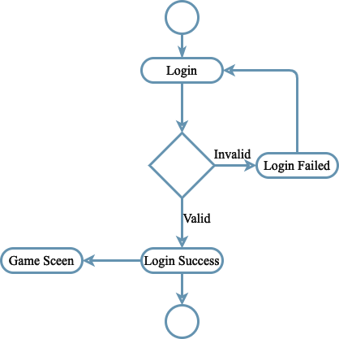

**Figure 4.7 State Transition Diagram (Login)**

A State Transition Diagram for the "Edit Settings" use case would typically involve representing the different states and transitions that occur when a player accesses and modifies the game settings.

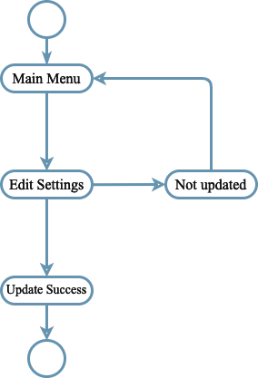

**Figure 4.8 State Transition Diagram (Edit Settings)**

State Transition Diagram for the "Join Lobby" use case involves representing the different states and transitions that occur when a player joins an existing multiplayer lobby to participate in online matches.

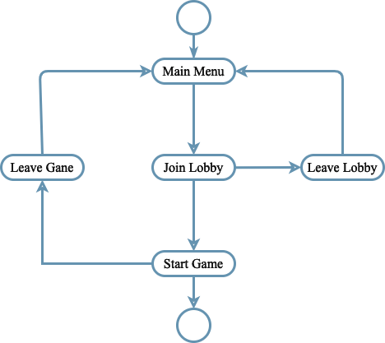

**Figure 4.9 State Transition Diagram (Join Game Lobby)**

A State Transition Diagram for the "Create Lobby" use case involves representing the different states and transitions that occur when a player creates a new multiplayer lobby to host a custom game session.

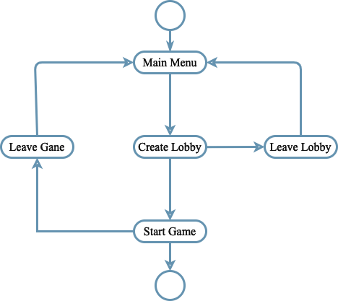

**Figure 4.10 State Transition Diagram (Create Lobby)**

A State Transition Diagram for the "Start Game" use case involves representing the different states and transitions that occur when a player initiates the beginning of a single-player or multiplayer match.

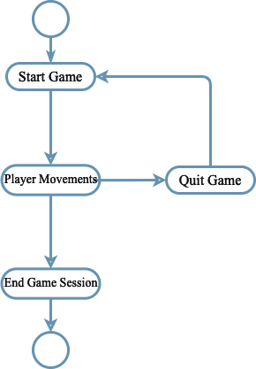

**Figure 4.11 State Transition Diagram (Start Game)**

The multiplayer shooting game comprises client-side components like User Interface, Game Logic, and Input Manager, and server-side components like Game Manager, Player Manager, and Physics Engine. Networking Modules handle communication, Data Serialization ensures data transmission, and external services provide authentication. Player information is stored in databases. Overall, the architecture enables a captivating multiplayer shooting experience.

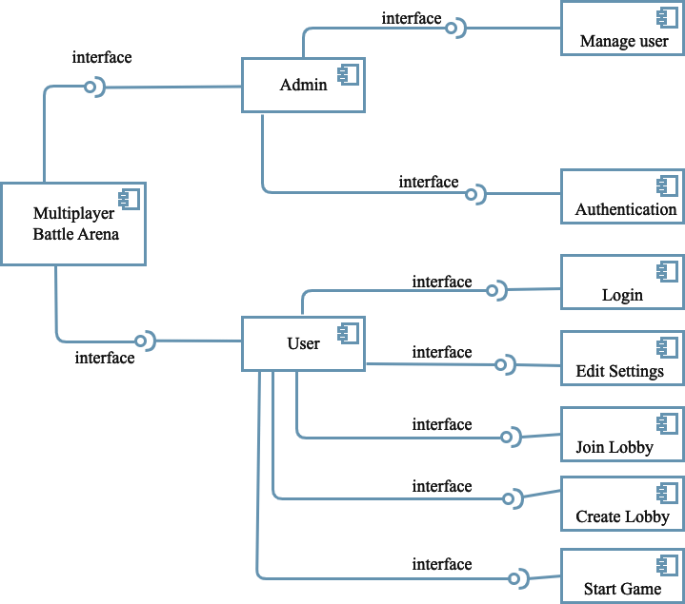

**Figure 4.12 Component Diagram**

The deployment diagram for the multiplayer shooting game shows Game Clients on devices, communicating with the Game Server running Game Manager, Player Manager, Physics Engine, and Matchmaking System. Networking Infrastructure facilitates data transfer, while External Services handle authentication. Databases store player accounts and game data, and a Game Assets Repository stores media files. Overall, this diagram visualizes the physical setup for delivering the multiplayer shooting experience.

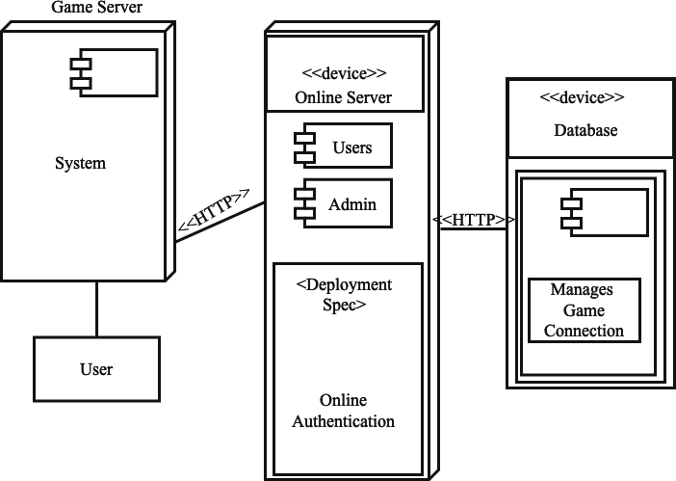

**Figure 4.13 Deployment Diagram**

### Splash Screen

Splash Screen is the first loading screen which always show when the game opened, during this loading screen game connected to the server. The splash screen of the shooting game is the initial screen that appears when the game is launched, serving as an introduction or loading screen before the main menu or gameplay. It often includes the game's logo, title, and perhaps some visual effects or animations.

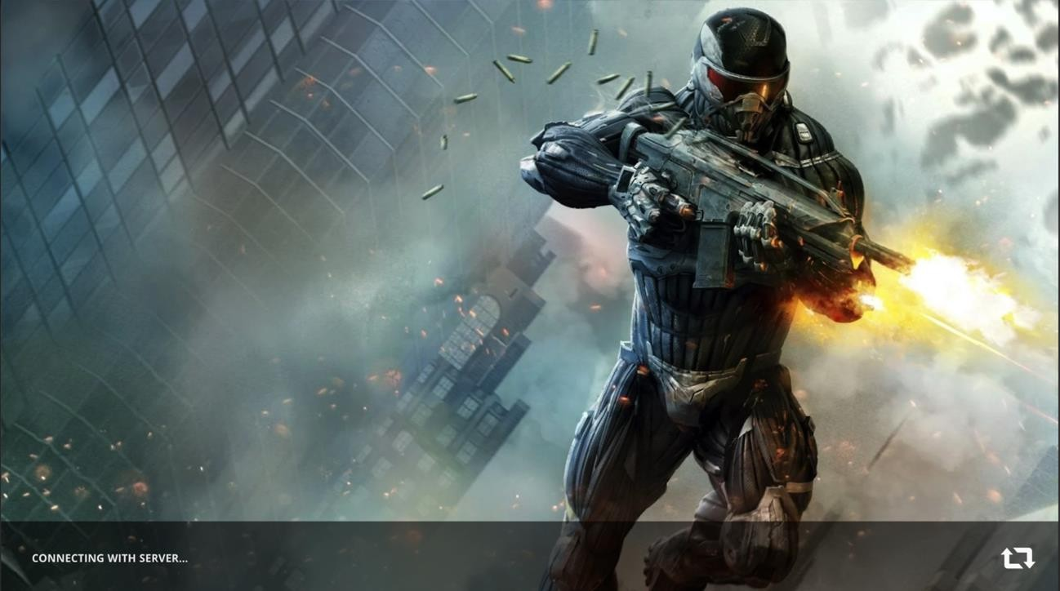

**Figure 4.14 Splash Screen**

The guest login screen of the shooting game is the initial screen that allows players to access the game without requiring them to create an account or log in with existing credentials. It offers a quick and hassle-free way for players to start playing the game as a guest. After splash screen, login screen appear in which automatically guest name appears user can change the name or login with the given name and click on continue button.

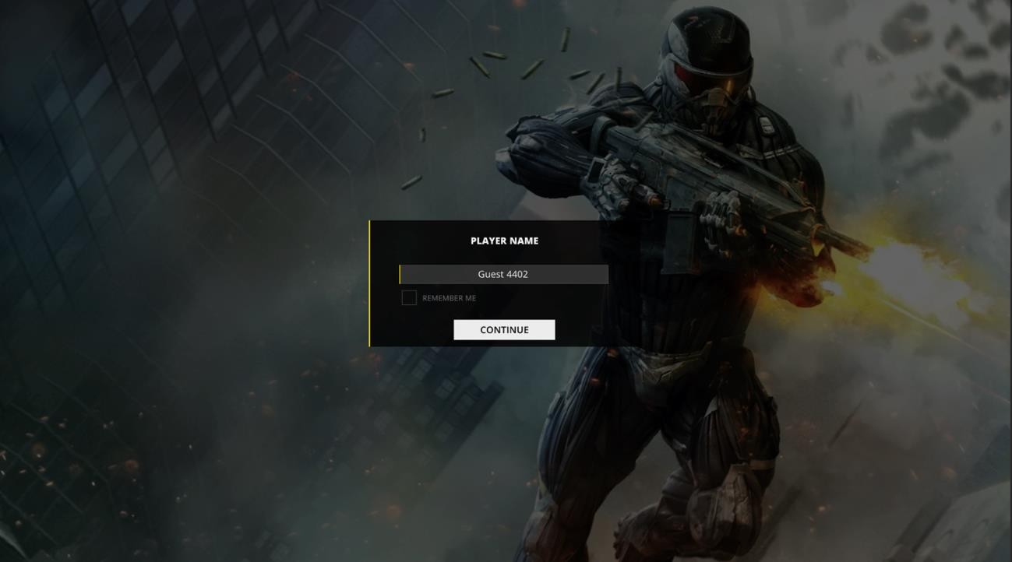

**Figure 4.15 Login Screen**

After successfully login, main menu screen will be on screen. Through main menu screen user can choose multiple options like:

* + - * Play
      * Options
      * Logout
      * Quit

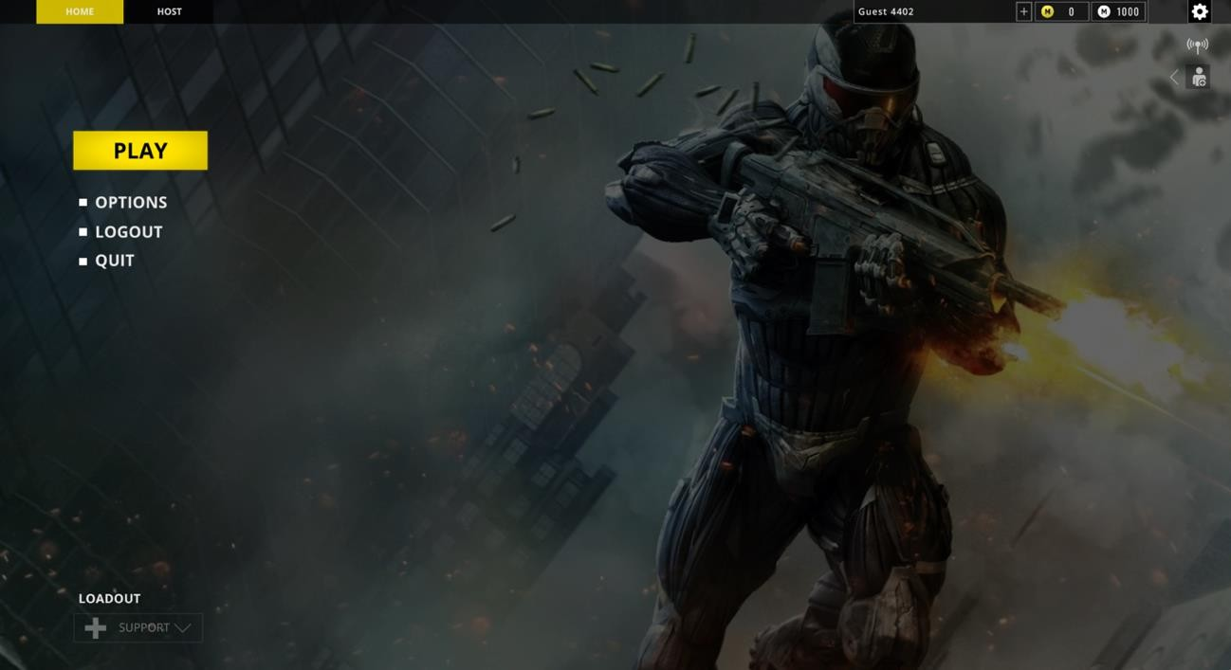

**Figure 4.16 Main Menu Screen**

In general settings, user can change 3 things, show frame rate, refresh rate in seconds and weapon projection according to his needs. Below the options include in general settings:

* + - * Show frame rate
      * Refesh rate
      * Weapon projection

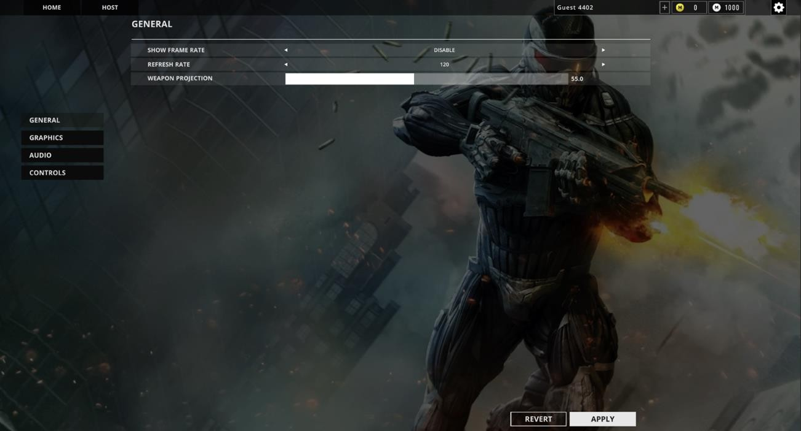

**Figure 4.17 General Settings**

In graphics settings, user can change the graphics settings according to his system requirements to run the game fast in his/her system. Some of the graphics settings includes:

* + - * Display mode
      * Resolution
      * Quality
      * Motion blue
      * Bloom

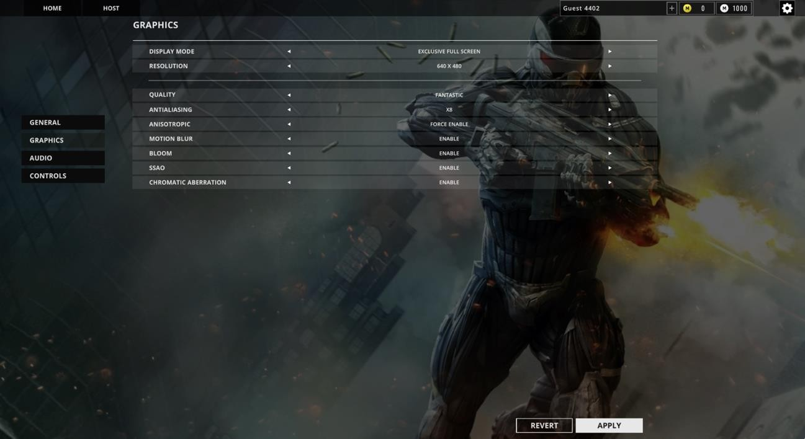

**Figure 4.18 Graphics Settings**

In audio settings, user can increase and decrease the volume and music of the game according to his needs. Audio Settings includes:

* + - * Audio
      * Volume
      * Music Colume
      * Voice Chat

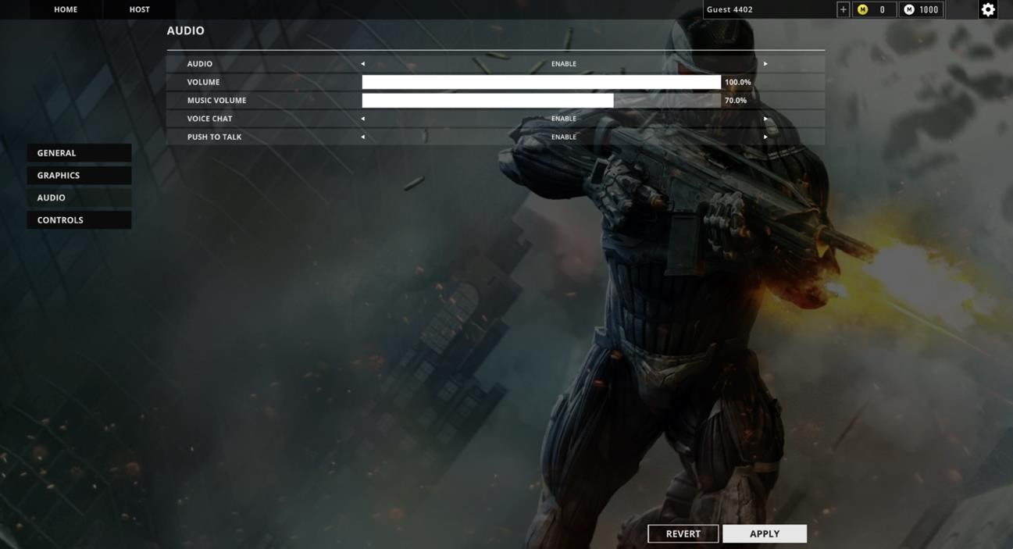

**Figure 4.19 Audio Settings**

In controls settings, user can change the controls buttons that is suitable for him/user. After change must click on apply otherwise control settings should not be saved. Some of the controls are given below:

* + - * Mouse Sensitivity
      * Aim Zoom
      * Device input source
      * Keyboard controls settings

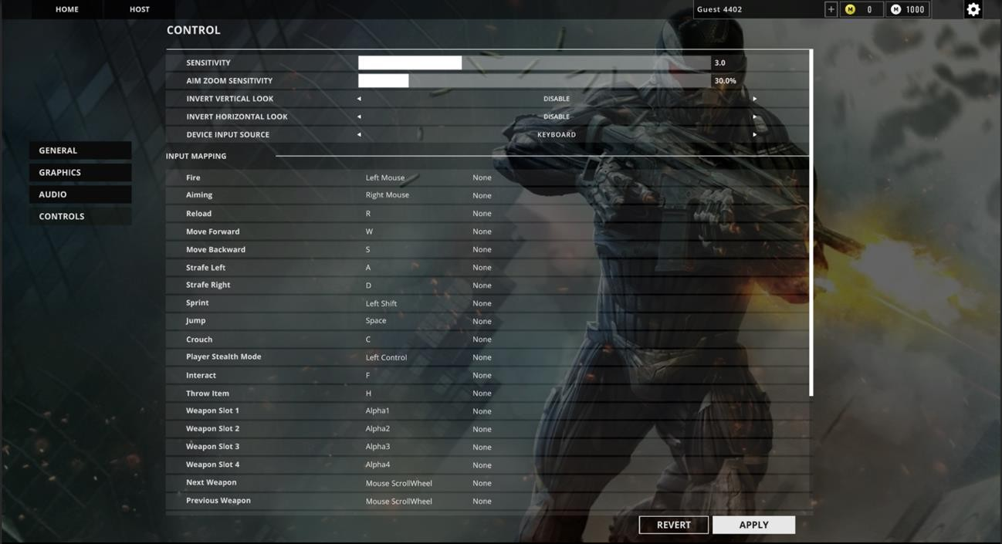

**Figure 4.20 Controls Settings**

Create lobby for the team death match must select the option of team death match while creating the lobby and click on create. Options to create this lobby includes:

* + - * Choose Team Death Match Mode
      * Select Players
      * Select Time
      * Select Bots
      * Select Game Mode Goal

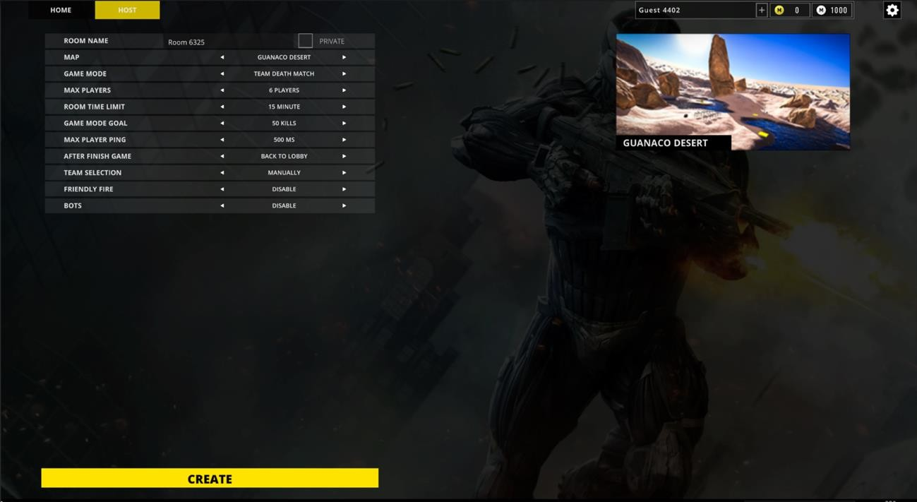

**Figure 4.21 Create Lobby Team Death Match Mode**

Create lobby for the Capture of Flag must select the option of team death match while creating the lobby and click on create. Options to create this lobby includes:

* + - * Choose Capture of Flag Mode
      * Select Players
      * Select Time
      * Select Game Mode Goal

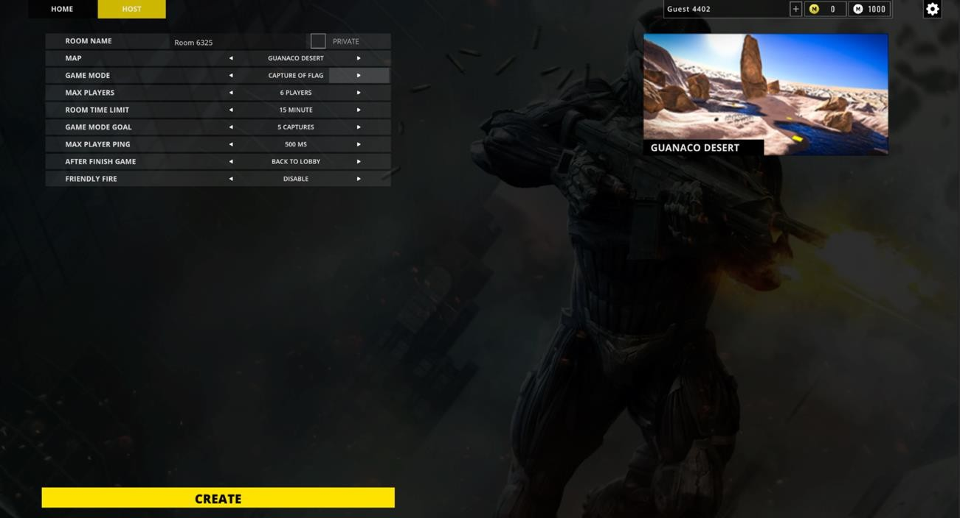

**Figure 4.22 Create Lobby Capture of Flags Mode**

Create lobby for the Free for all mode user must select the option of team death match while creating the lobby and click on create. Options to create this lobby includes:

* + - * Choose Free for All Mode
      * Select Players
      * Select Time
      * Select Game Mode Goal
      * Enable/Disable Bots

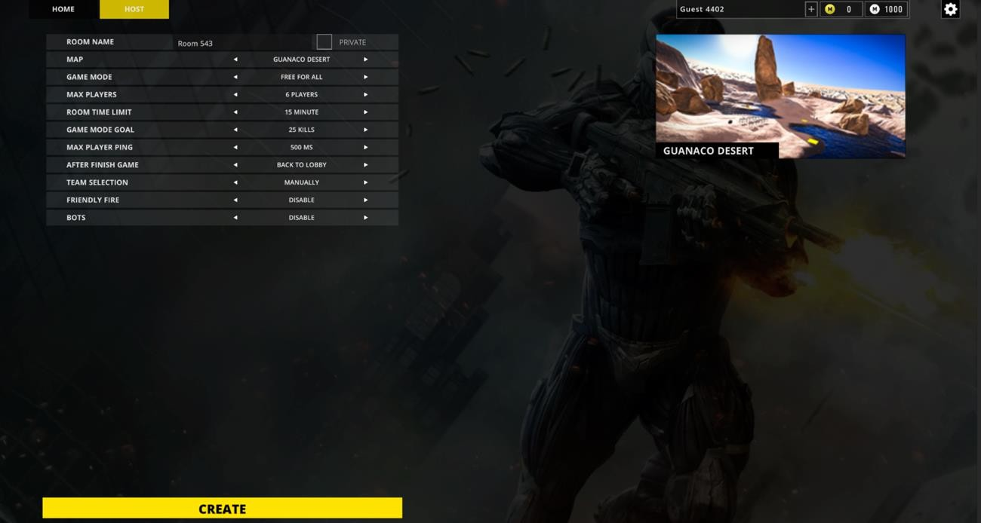

**Figure 4.23 Create Lobby Free for All**

The lobby screen in a shooting game is a central hub where players gather before entering multiplayer matches. It serves as a meeting point for players to form teams, choose game modes, customize loadouts, and interact with each other. Start the game from the lobby, user have to click on start button to play the game.

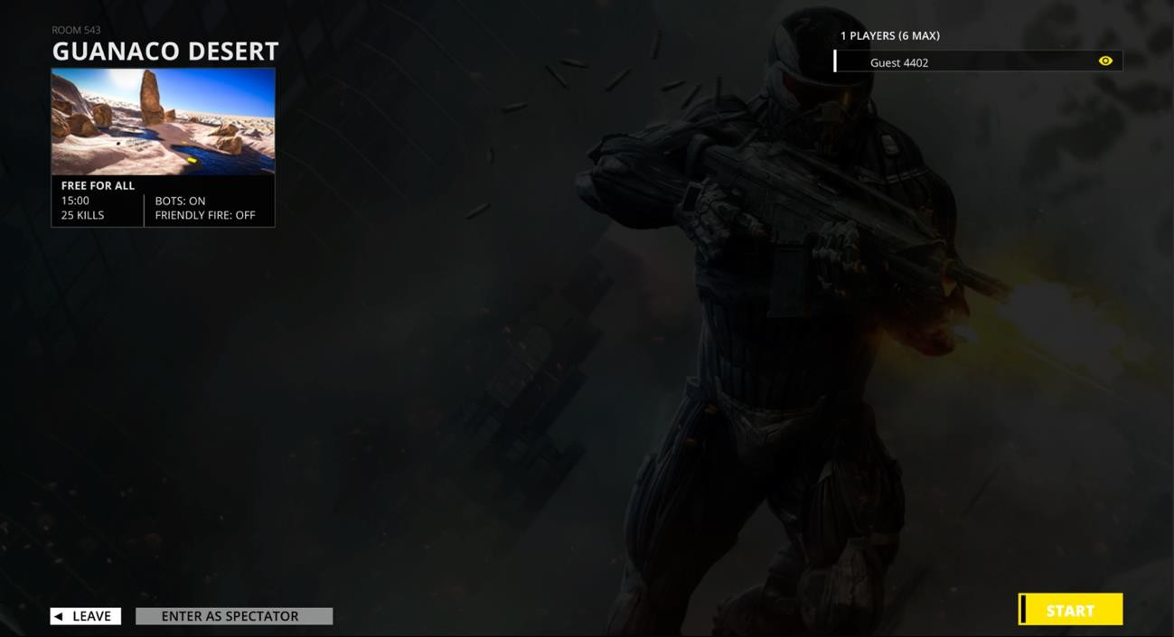

**Figure 4.24 Lobby**

Gameplay screen where user can play the game and kill other enemies to win the game. Here user can:

* + - * Move
      * Shoot
      * Reload
      * Crouch
      * Run
      * change weapons
      * pick/drop weapons
      * exit the current game session

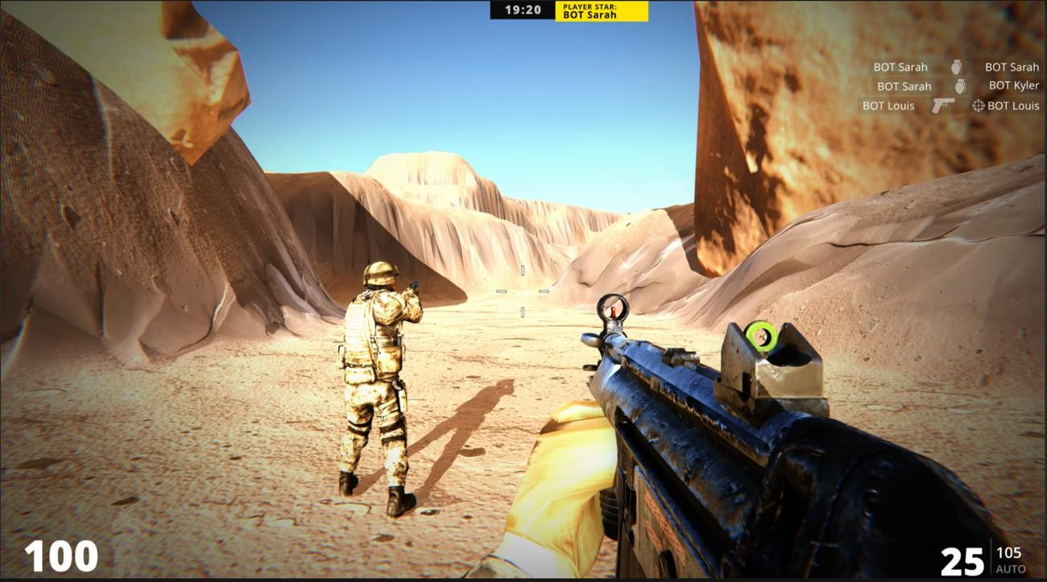

**Figure 4.25 Gameplay**

The scoreboard in a multiplayer shooting game is a visual representation of the current standings and performance of players or teams during a match. It provides valuable information about their kills, deaths, assists, and other relevant statistics. By click “TAB” button, user can see the scoreboard of the current gameplay session.

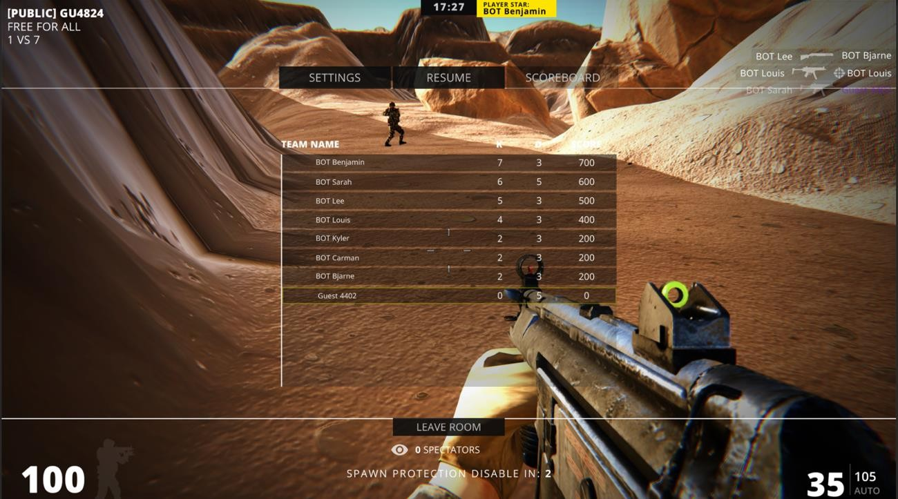

**Figure 4.26 Scoreboard**

# CHAPTER 5 IMPLEMENTATION

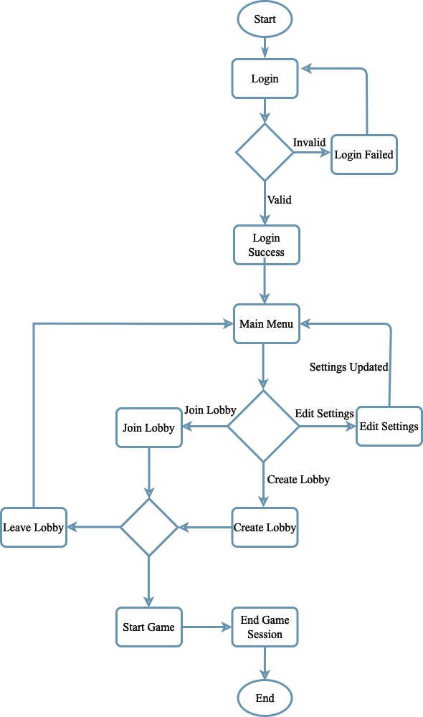

**Figure 5.1 Important Flow Control**

### Libraries

Libraries are a collection of diverse functions that are utilized in the creation of a project to make the various functions easier to perform. The functions are linked to the libraries, making it simple to conduct tasks across many activities. A list of the many libraries used in our project is provided below.

* Unity Libraries
* Photon Unity Networking

## Deployment Environment

* + - Unity 3D
    - C#
    - Android Studio
    - Visual Studio
    - MacOS Montery

## Tools and Techniques

* + - C#
    - Android Studio
    - Visual Studio
    - Unity 3D
    - Photon Unity Networking
    - Blender
    - Adobe Illustrator
    - Code should not have any trailing whitespace to avoid creating unnecessary diff issues.
    - Function and classes are always commented on showing expected input and output
    - GUI should be user-friendly
    - Let photos say what you can’t say
    - Document everything
    - Demand for Feedback

# CHAPTER 6

**TEST AND EVALUATION**

Testing is a procedure for detecting problems in a program. We execute a simulation test on the system to ensure that any errors or bugs are not there. Various scenarios and forms of testing will be used to determine whether or not the system is functioning properly. If any faults are discovered throughout the testing, provide a solution to the errors. In this chapter, we cover the entire system testing and assessment process, including how to use the system and what work each feature has completed.

## Use Case Testing

Various scenarios, such as user and multiplayer functionality, are being tested throughout this session.

Use Case Testing is a software testing technique that helps to identify test cases that cover entire system on a transaction-by-transaction basis from start to end. Test cases are the interactions between users and software application. Test **cases** based on use cases and are referred as scenarios. Capability to identify gaps in the system which would not be found by testing individual components in isolation. Very effective in defining the scope of acceptance tests.

**Table 6.1 Use Case Testing-01**

|  |  |  |  |
| --- | --- | --- | --- |
| **Actor:** | **User** |  |  |
| **No.** | | **Steps** | **Description** |
| 1 | | Login | Login to the system with guest name  System will redirect to next page |
| 2 | | Edit Settings | Change the settings of the game according  to your systems and your mindset |
| 3 | | Create Game Lobby | Create game lobby according to your  interest. |
| 4 | | Join Lobby | Join any random lobby to play the game. |
| 5 | | Start Game | Start the game-play and kill the enemies to  win the game. |
| 6 | | Logout | Logout success with press logout button  System will redirect to login page |

The main success scenario of a multiplayer shooting game outlines the sequence of events that occur during a typical and successful gameplay experience. The main success scenario ensures that players have an engaging and enjoyable experience, with challenging gameplay, opportunities for teamwork, and a sense of progression. The game's mechanics, visuals, and level design all contribute to creating a thrilling multiplayer shooting game that keeps players coming back for more action and excitement.

**Table 6.2 Use Case Testing Extension**

|  |  |  |
| --- | --- | --- |
| **No.** | **Step** | **Description** |
| **1-a** | Login failed | Login failed if user did not have internet.  System will display an error message |
| **2-a** | Lobby connection  failed | Lobby connection failed if your internet  connection is not stable |
| **3-a** | Lobby suddenly leave | Lobby suddenly leave if your internet  connection lost during game |
| **4-a** | Lobby created failed | Lobby creation failed if your internet  connection is not stable. |
| **5-a** | Game-play stucks | Game-play stucks if your internet  connection lost. |

## Boundary Value Analysis

Boundary testing is a type of testing that takes place between a starting point and the extreme ends of a range of input values, or between partials of input values.

##### Login Username

* + - A person's username must be unique when entering it in the text field during login.

##### Text Fields

* + - The system must allow only correct text in all text fields.
    - The user must add only the information that is required and brief.
    - Name is examples of text fields.

### Test Case Title: System Response Time Testing

**Table 6.3 Performance Testing 01**

|  |  |  |
| --- | --- | --- |
| **Test Type** | **Performance Testing** | **Test Result** |
| Required performance | The required response time of the  system is less than 10 seconds |  |
| System performance | The actual performance response time  is 5 seconds. | Test passed |

### Test Case Title: Activity Load Time Testing

**Table 6.4 Performance Testing 02**

|  |  |  |
| --- | --- | --- |
| **Test Type** | **Performance Testing** | **Test Result** |
| Required performance | The required page load time of  the system is less than 5 seconds |  |
| System performance | The actual page load time is 2  seconds. | Test passed |

**Table 6.5 Performance Testing 03**

|  |  |  |
| --- | --- | --- |
| **Test Type** | **Performance Testing** | **Test Result** |
| Required performance | System should perform normally and efficiently with a large number of  users |  |
| System performance | System performed all activities  normally with a large number of users. | Test passed |

### Test Case Title: Waiting Time Testing

**Table 6.6 Performance Testing 04**

|  |  |  |
| --- | --- | --- |
| **Test Type** | **Performance Testing** | **Test Result** |
| Required performance | The average waiting time of the  system is less than 5 seconds |  |
| System performance | The actual performance response  time is 3 seconds in some circumstances. | Test passed |

**Table 6.7 Performance Testing 05**

|  |  |  |
| --- | --- | --- |
| **Test Type** | **Performance Testing** | **Test Result** |
| Required performance | The connection must be established  in less than 3 seconds |  |
| System performance | The actual connection establishes time is about 2 second. | Test passed |

### Test Case Title: Database Send/Get Information Time Testing

**Table 6.8 Performance Testing 06**

|  |  |  |
| --- | --- | --- |
| **Test Type** | **Performance Testing** | **Test Result** |
| Required performance | The system should save or retrieve  data from database in less than 2 seconds. |  |
| System performance | The actual time system sends or gets information to database in 1  second. | Test passed |

Stress testing is a method of determining a system's stability and dependability. Stress testing is a technique for determining a system's ability to handle flaws and faults. Stress testing is a technique for evaluating a system's ability to handle errors under harsh conditions.

We overload our system and analyze its behavior in extreme settings to confirm that it behaves normally during stress. In bad conditions, the (Multiplayer Battle Arena) Game behaves regularly, and all of its features and functions work as expected.

Through this testing, we monitor our system and make sure our system

* System should save all data before crashing
* Make sure the connection from server
* If server0 no response, wait on login current page

As we all know, there is always room for improvement in every management system. The following are some basic changes that we should make in the future:

##### Add More Environments

To improve the game difficulty and enjoyment, need to add more environments that will be selectable by users. The more levels to get, the more user will play.

##### Game Quality

For use, quality is quite crucial. Always keep a close eye on quality control and never skimp on it. The higher the quality, the better.

##### System Level

Our system should not be clogged with too much data. We should only give the user with the most basic information. Otherwise, the user may feel perplexed and will be unable to use our game.

##### Add More Modes

Besides the 3 Modes, I am thinking to add more new mods in the multiplayer game to enjoy more in the game.

# REFERENCES

1. Technologies, U. (2023, 7 7). Unity Manual. Retrieved from Unity Documentaion: https://docs.unity3d.com/Manual/index.html
2. Systems, A. (2021, 9 15). Character. Retrieved from Mixamo: https://[www.mixamo.com/#/](http://www.mixamo.com/%23/)
3. Shutterstock. (2021). Turbo Squid. Retrieved from Turbo Squid: https:/[/www.turbosquid.com/](http://www.turbosquid.com/)
4. Free3D. (2014, 12 9). Retrieved from Free3D: https://free3d.com/
5. Google. (2005, 2 14). Youtube. Retrieved from Youtube: https:/[/www](http://www.youtube.com/).[youtube.com/](http://www.youtube.com/)
6. GitHub, I. (2022, August). Github. Retrieved from Github: https://github.com/
7. Technologies, U. (2018). assetstore. Retrieved from Unity assetstore: https://assetstore.unity.com/
8. Wikipedia. (n.d.). Wikipedia. Retrieved from Wiki Pedia: https:/[/www.wikipedia.or](http://www.wikipedia.org/)g[/](http://www.wikipedia.org/)
9. Brakeys. (2012, December 23). Brackeys. Retrieved from Youtube: https:/[/www](http://www.youtube.com/channel/UCYbK_tjZ2OrIZFBvU6CCMiA).[youtube.com/channel/UCYbK_tjZ2OrIZFBvU6CCMiA](http://www.youtube.com/channel/UCYbK_tjZ2OrIZFBvU6CCMiA)
10. Data, R. (1999). cs/index.php. Retrieved from w3schools: https://[www.w3schools.com/](http://www.w3schools.com/)